EDUNEXA 
User Interface
- When the user accesses the link, the user is able to see the EduNexa Home page
- On the header, it has the following button options:
- Home
- Register
- Login
- About Us
- Contact

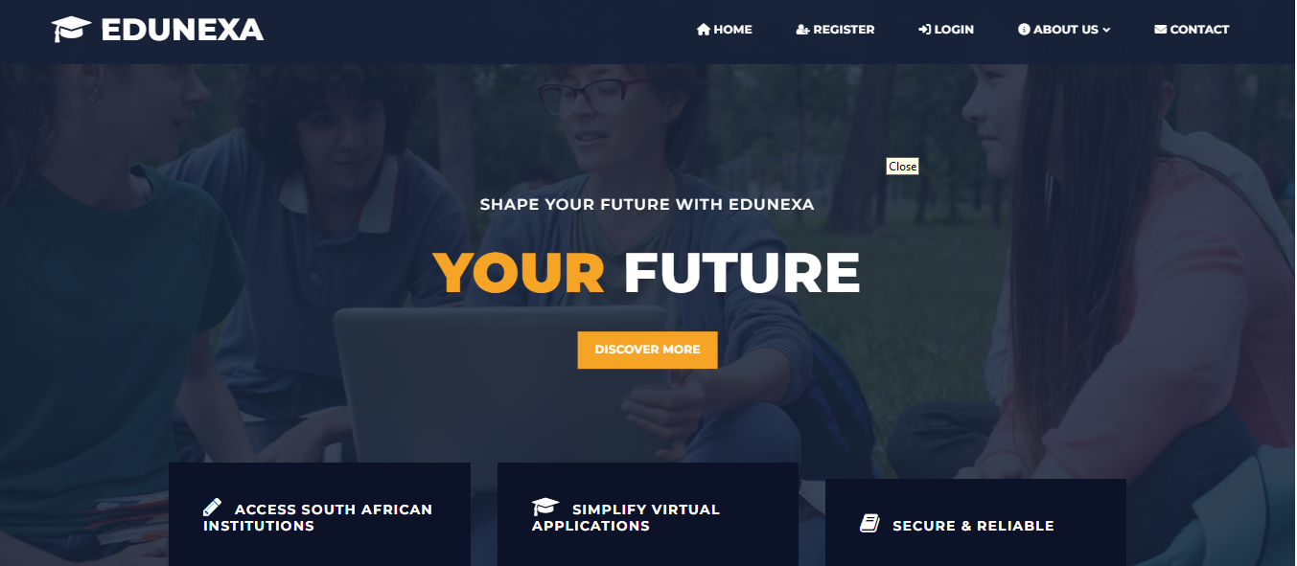

- On the bottom of the page there are reasons on why you should choose EduNexa to help you apply
- The reasons are shown using the following guide:
- Guidance for every student
- Time and Cost savings
- Trusted Student companion
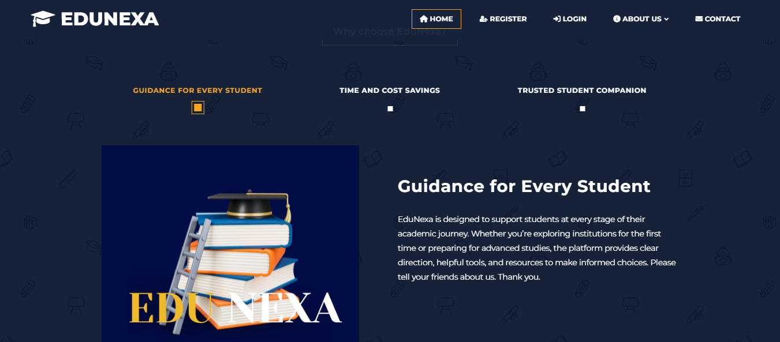
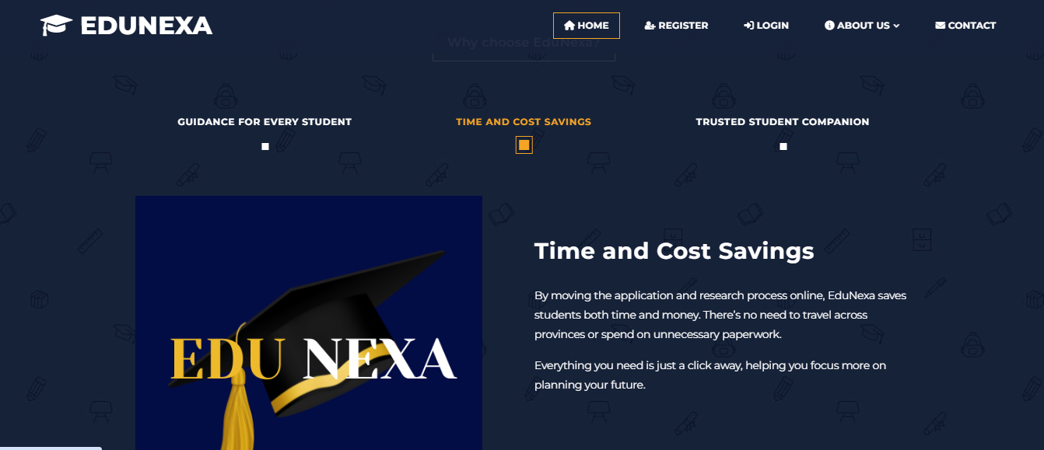
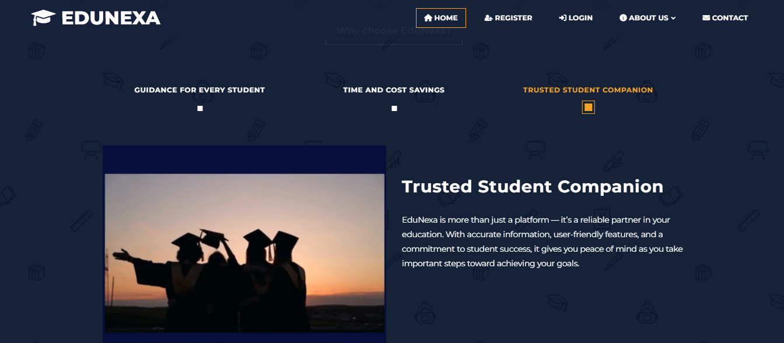
- When the Register button is clicked, the user is able to register on the EduNexa system
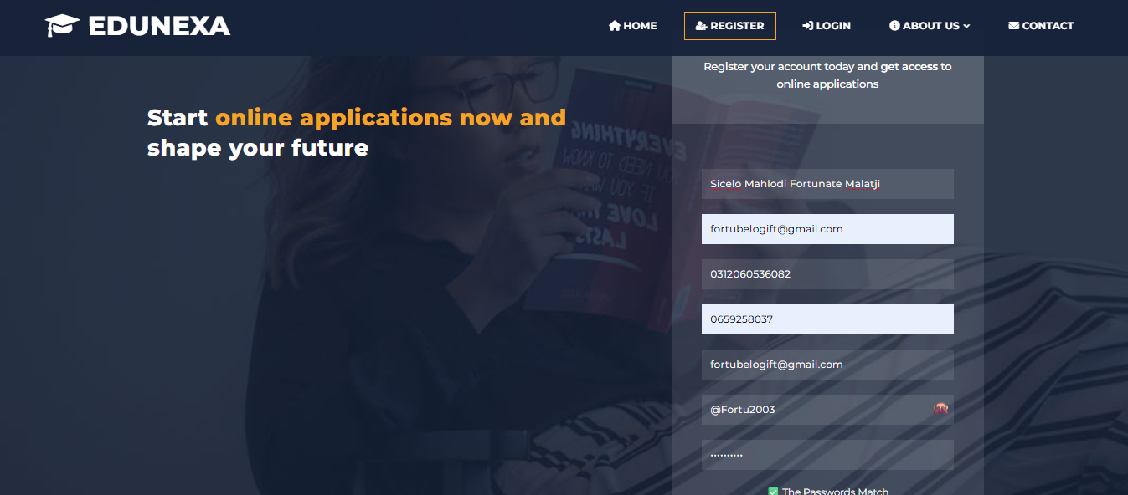
- On the bottom of the Home page, there’s a motivational Quote and a 2 mins video on why Education is important to everyone regardless of their race
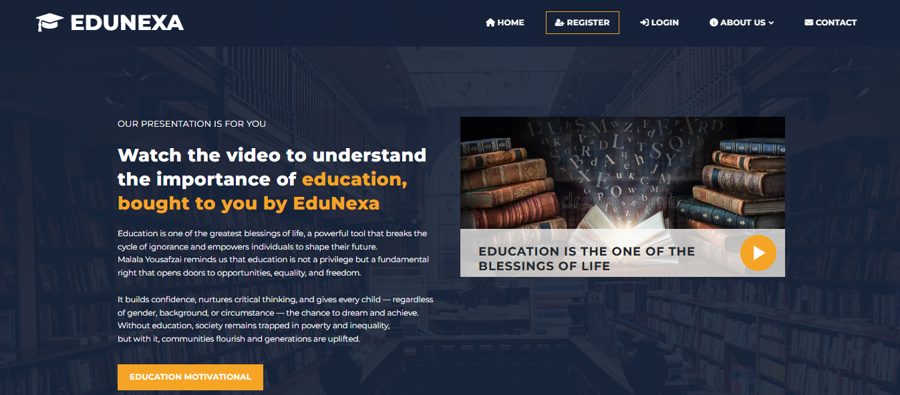

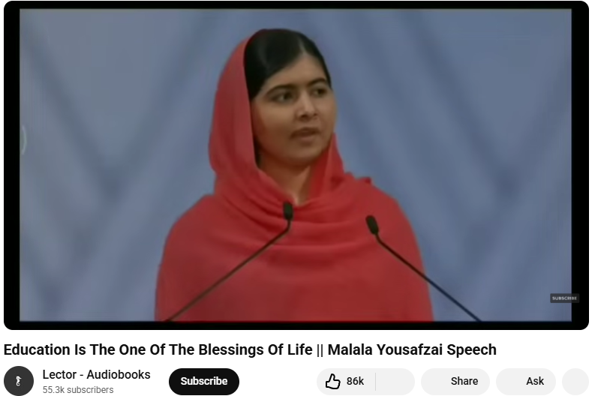

- The user is able to Login after successful Registration

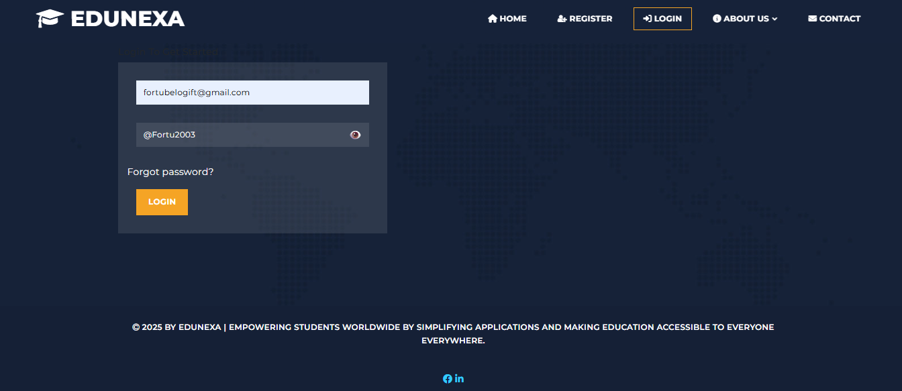

- The user can click the Forgot Password? link that will redirect the user to enter the Email that was used to register on the EduNexa system
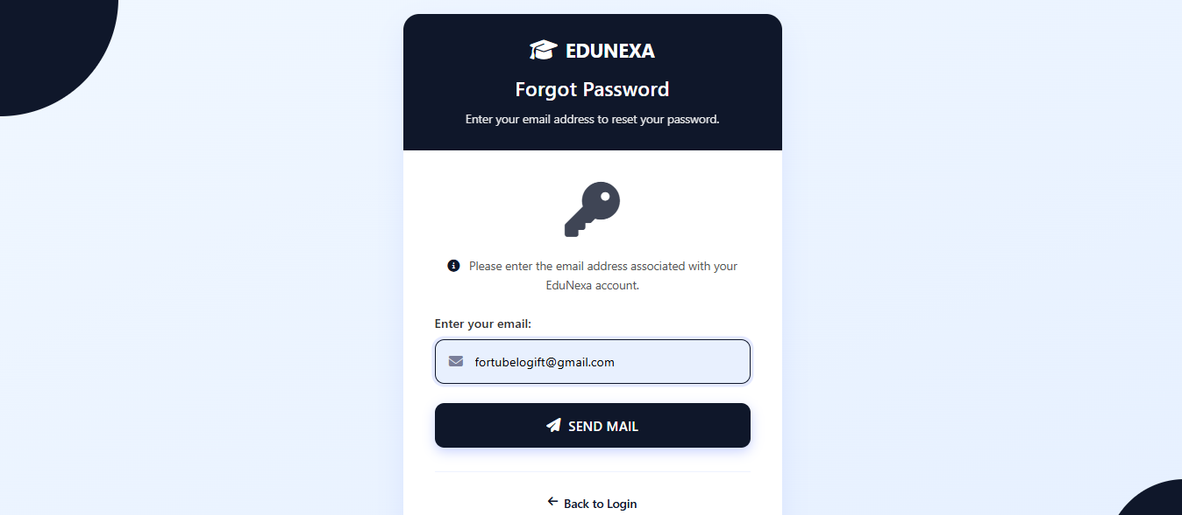
- After the Send Email button is clicked, the user will receive the email from EduNexa that says Reset your password
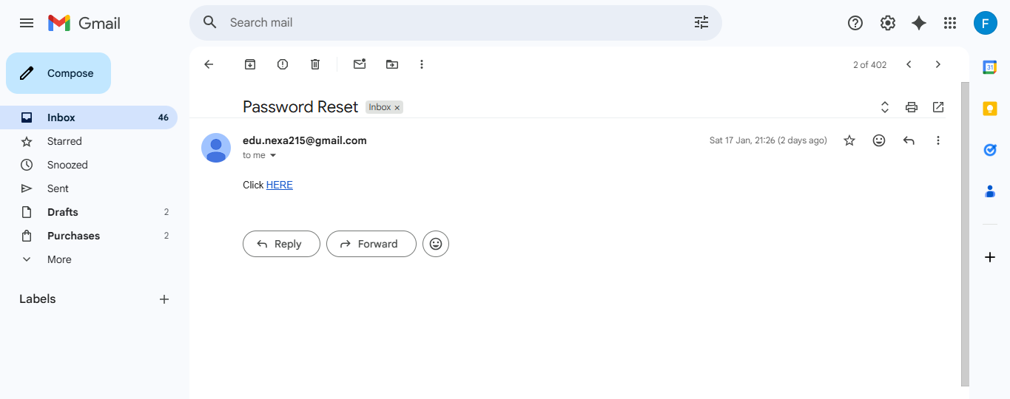

- EduNexa has a page on Facebook
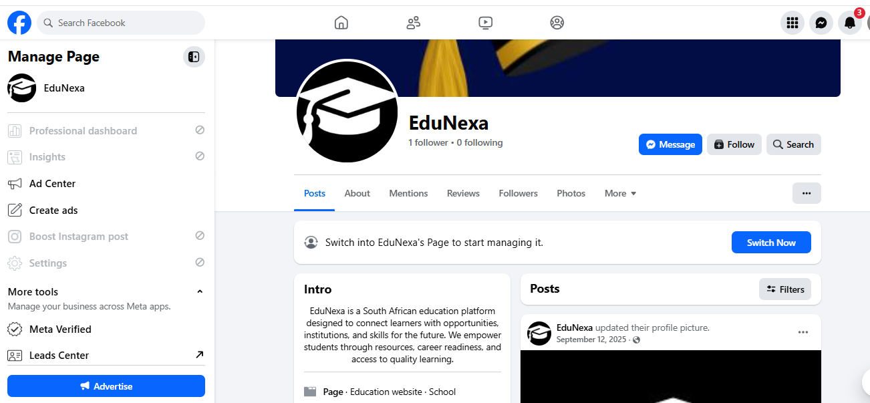

- EduNexa has a page on LinkedIn
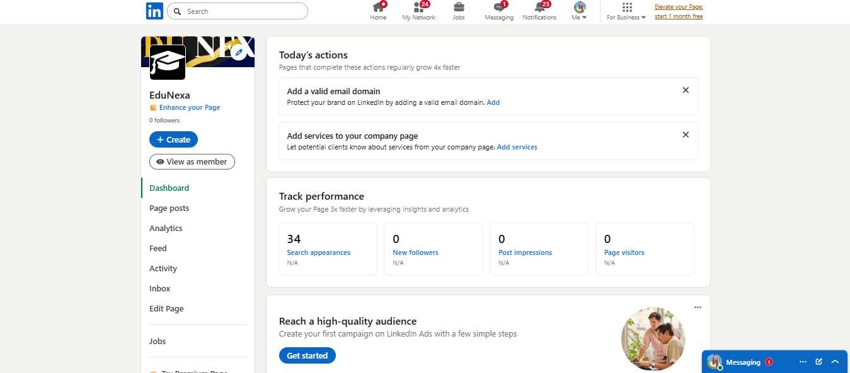
- The user is able to see the EduNexa About Us page without having to LogIn
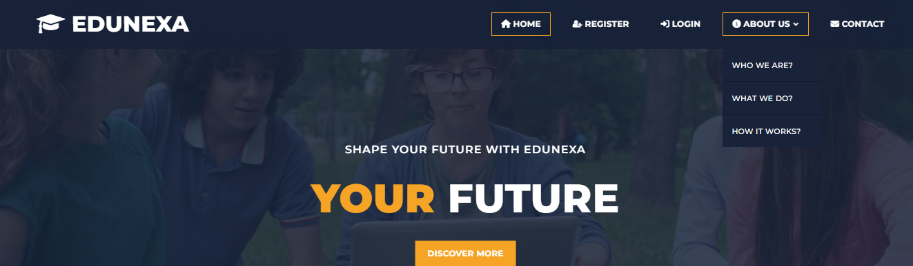

- When the About Us button is clicked, all the information the user wants to know about EduNexa is there
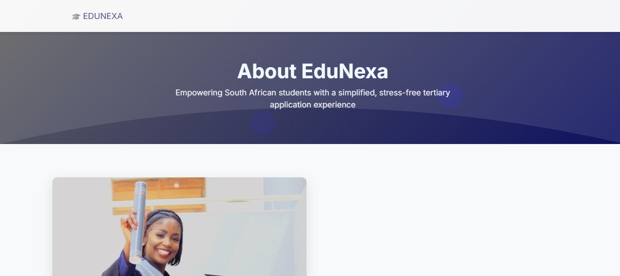

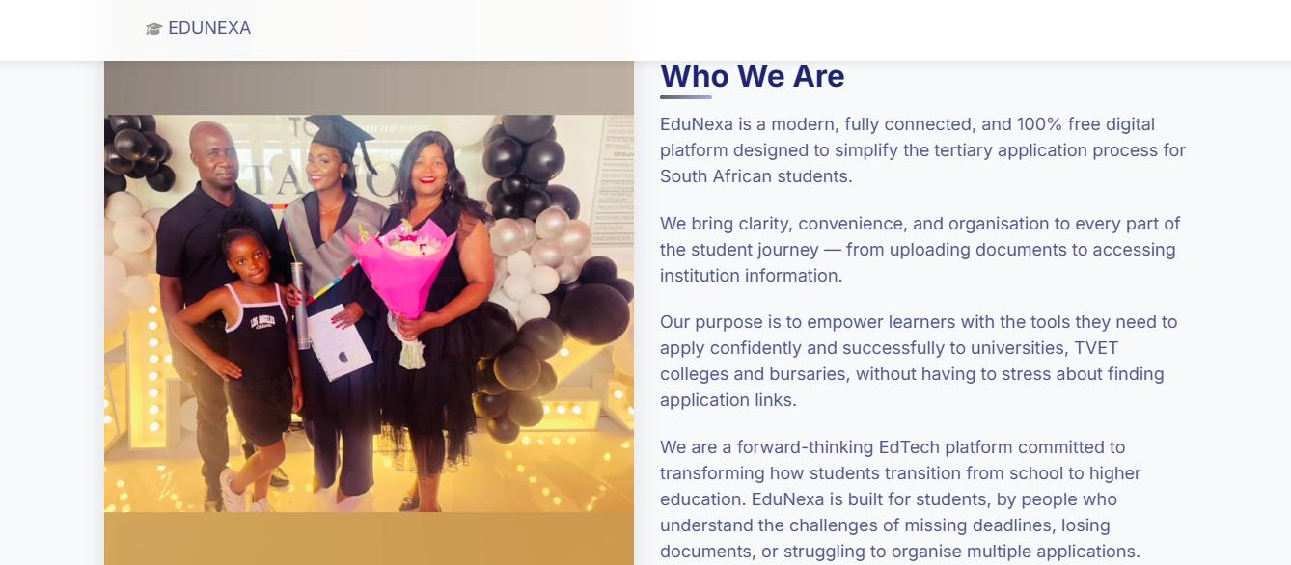
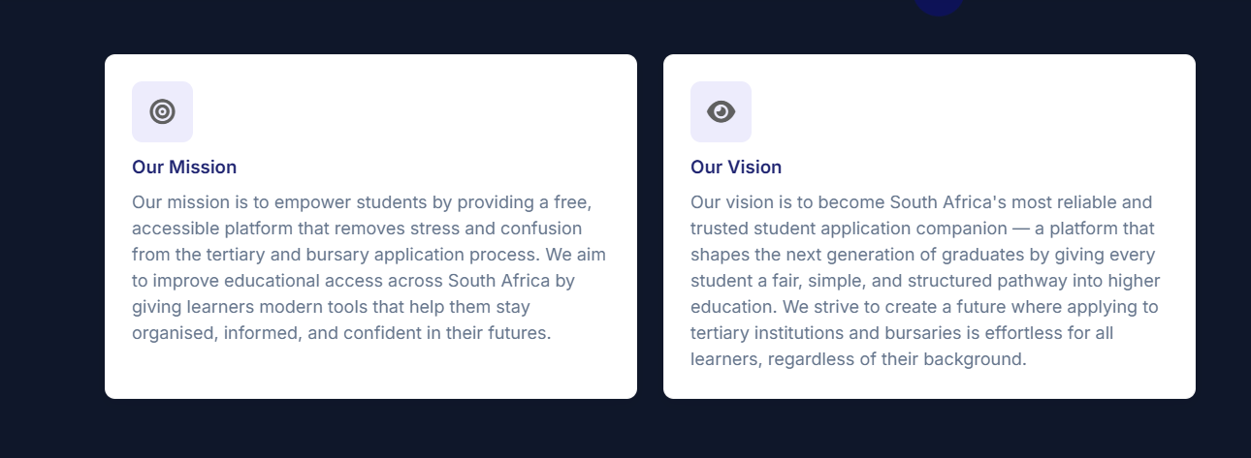

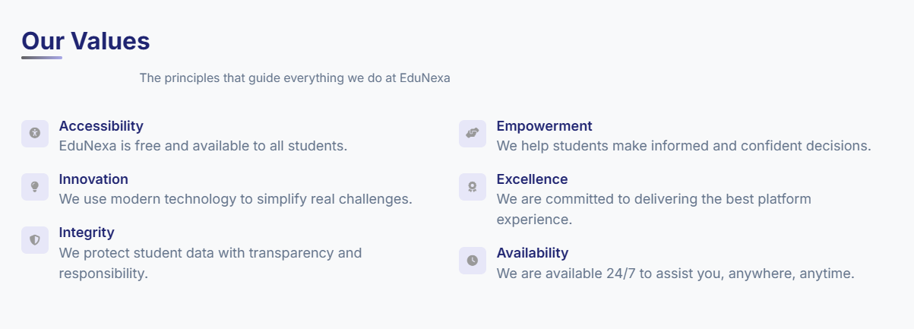

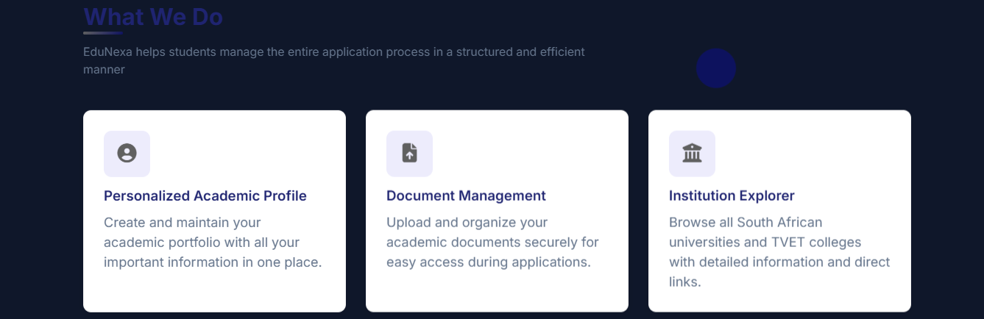

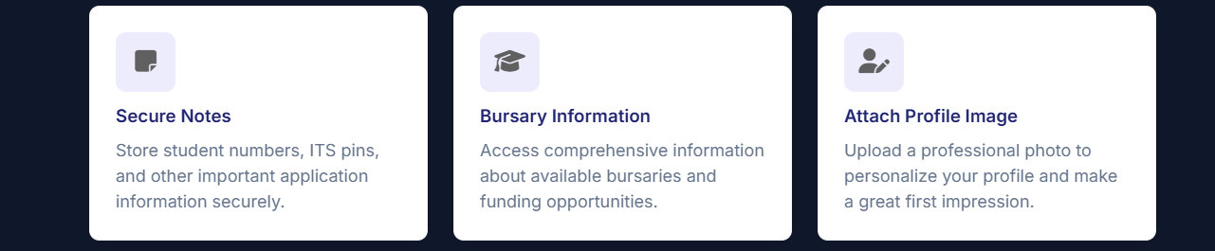

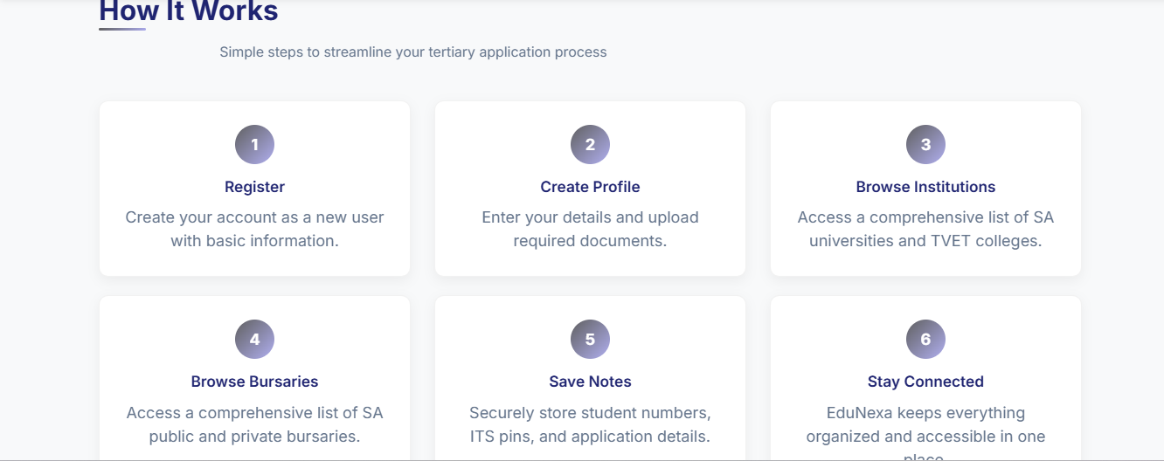
- On the bottom of the About Us page, the footer is there that can redirect the user to any page
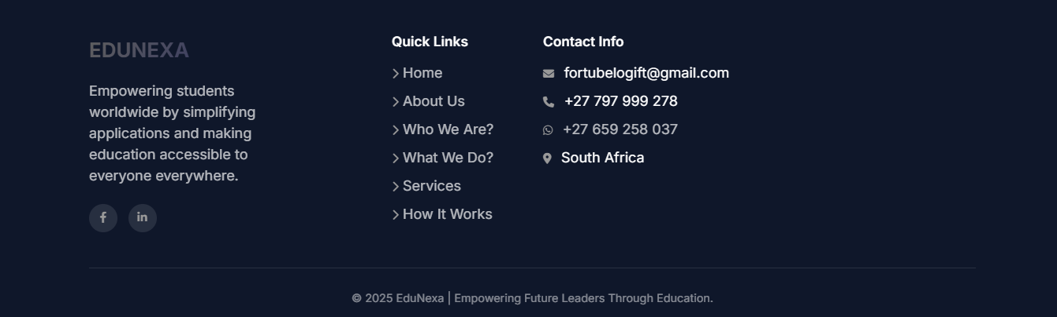

- EduNexa also has the Contact Us page if the user wants to verify that the link to EduNexa is not malicious

- The user can send EduNexa a message to make Queries about the system then the Admin will see it in the EduNexa Gmail to work on the made Queries
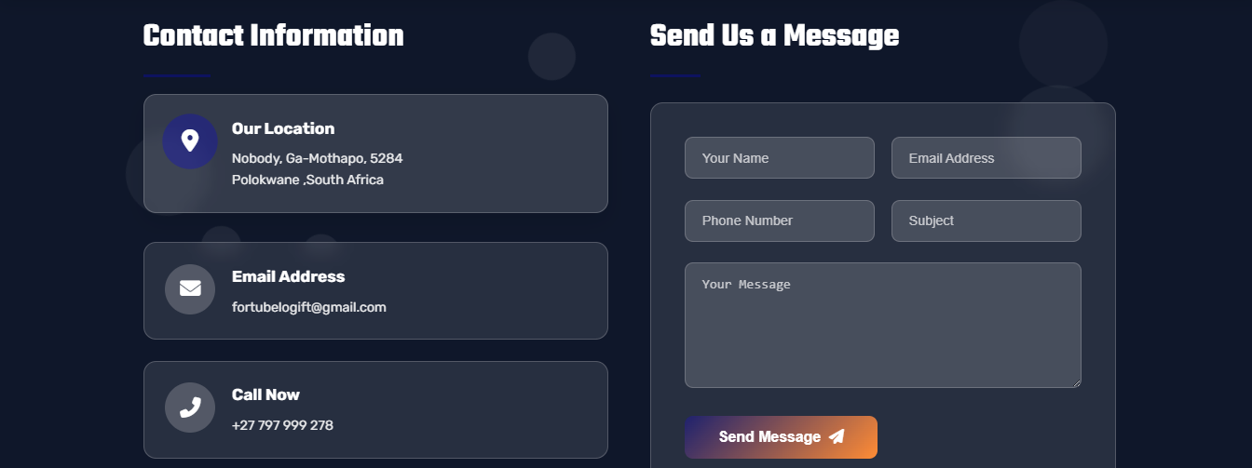
- The user is able to see the Home Address of the Developer
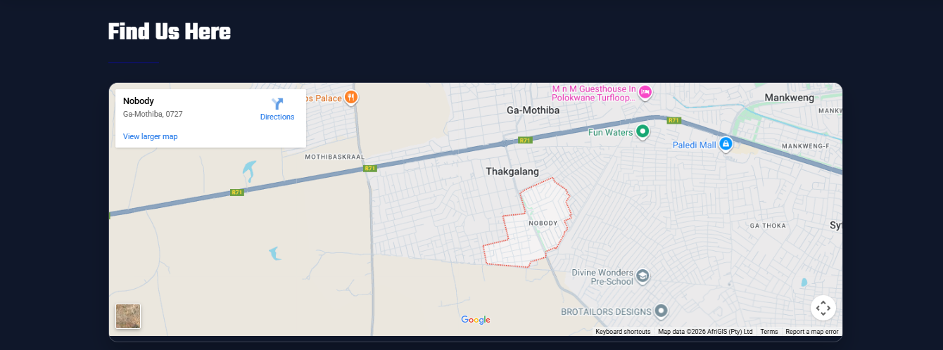

- The footer of the About Us page is the same as the Contact page
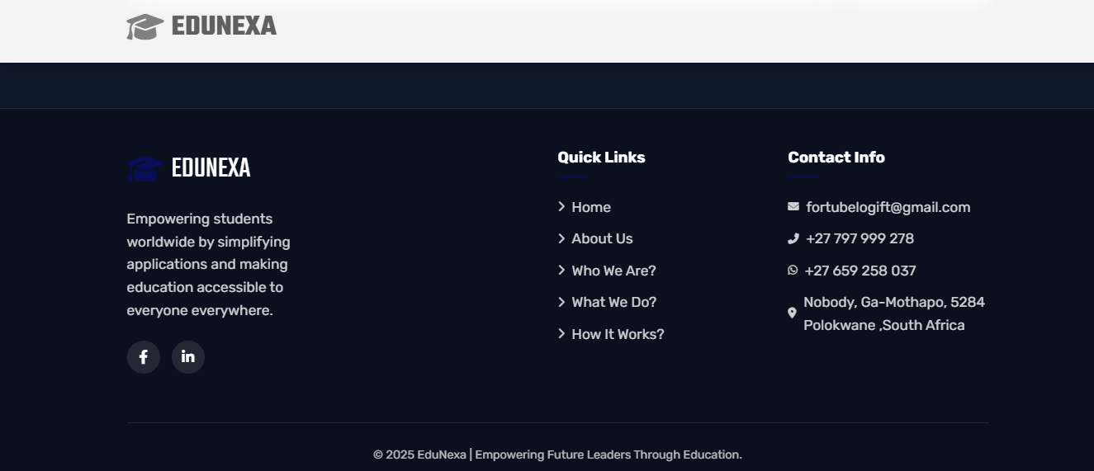
- All the user Queries are visible on the EduNexa Gmail account
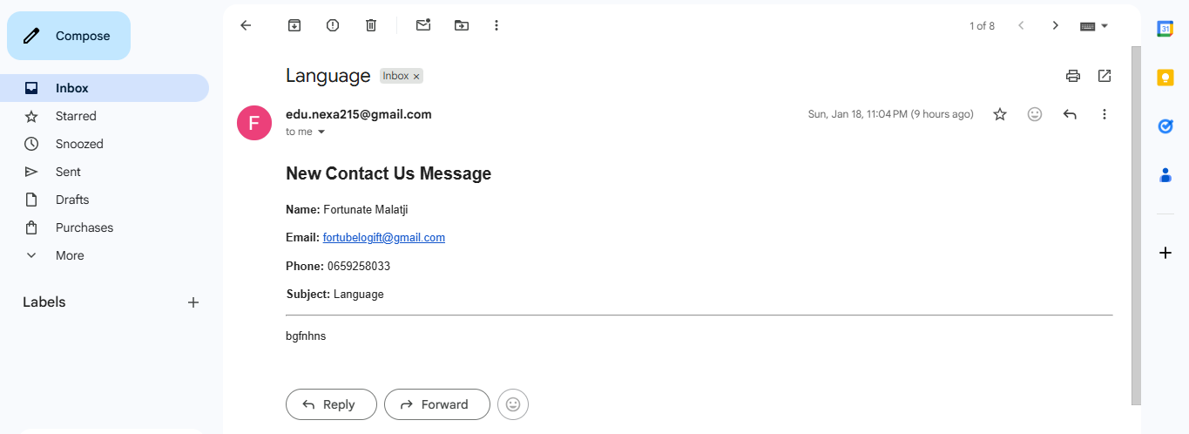

- After successful LogIn, the user is redirected to the User Welcome Page
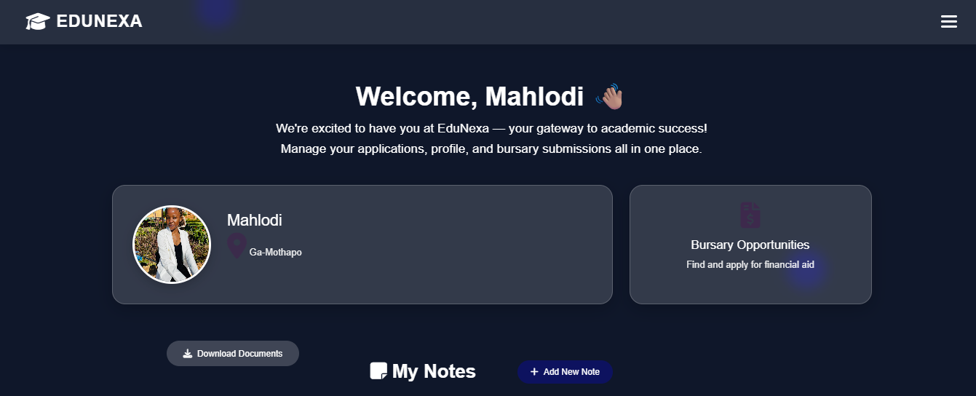
- The nav-bar has the below options:
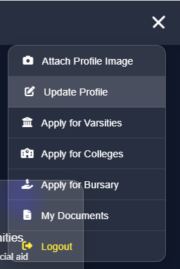

- The user can click the Attach Profile Image option, to attach their image to feel welcomed and familiar with the system
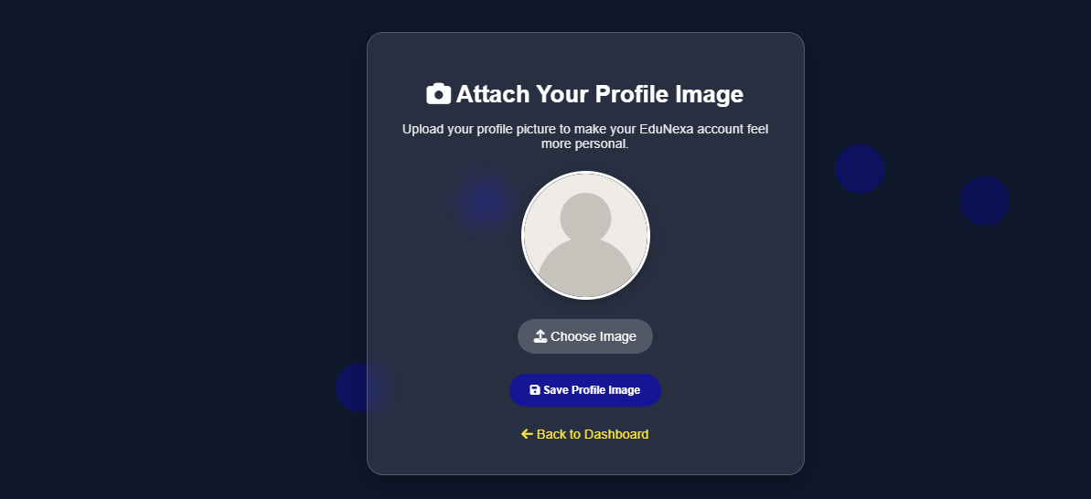
- The user can click the Update Profile option, to enter their address and also to Edit their details
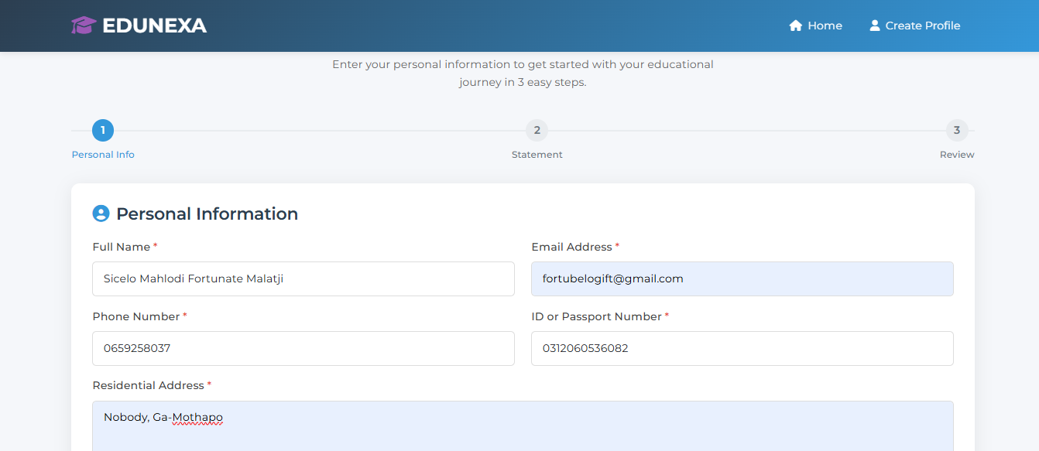

- After the Next button is clicked, the user is able to enter the Personal Statement that motivates them or any statement about themselves
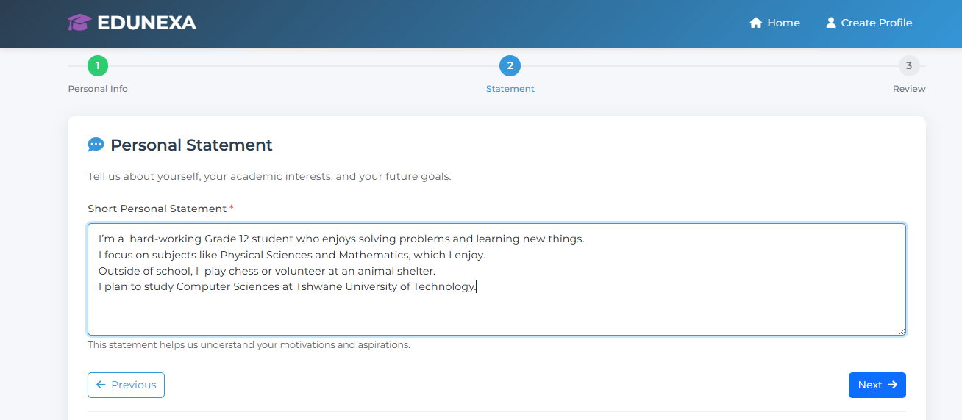
- After the Next button is clicked, the user then confirms that all the provided information is correct
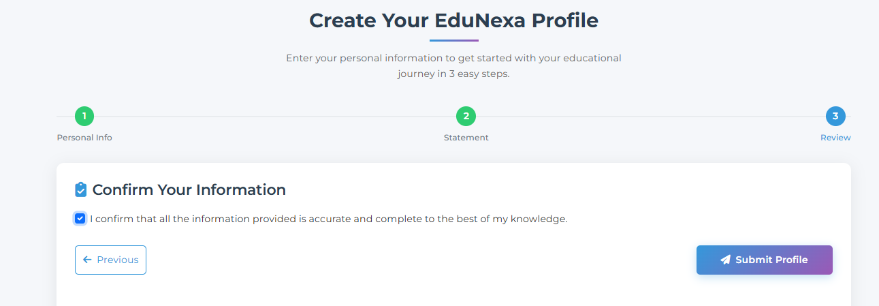

- The user then clicks the Submit Profile button to save their information and be redirected to the user welcome page
- The user can click Apply for Varsities option, that redirects the user to most of the South African varsities
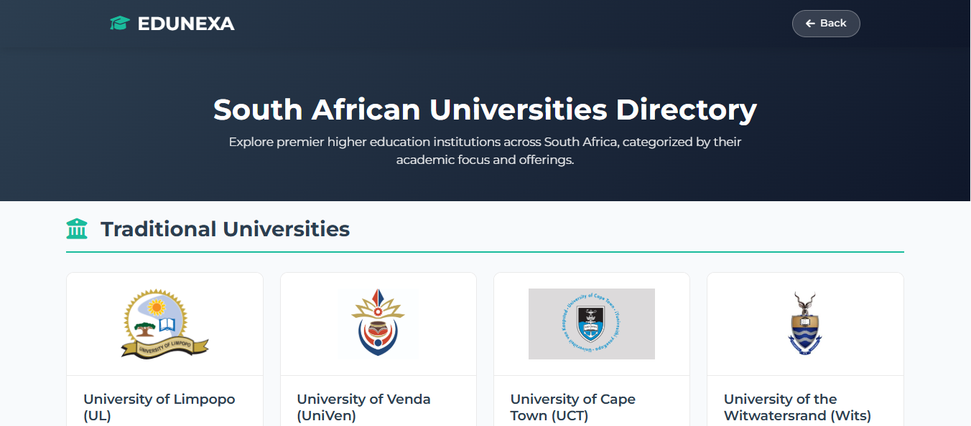
- The user can click Apply for Colleges option, that redirects the user to most of the South African private/public colleges
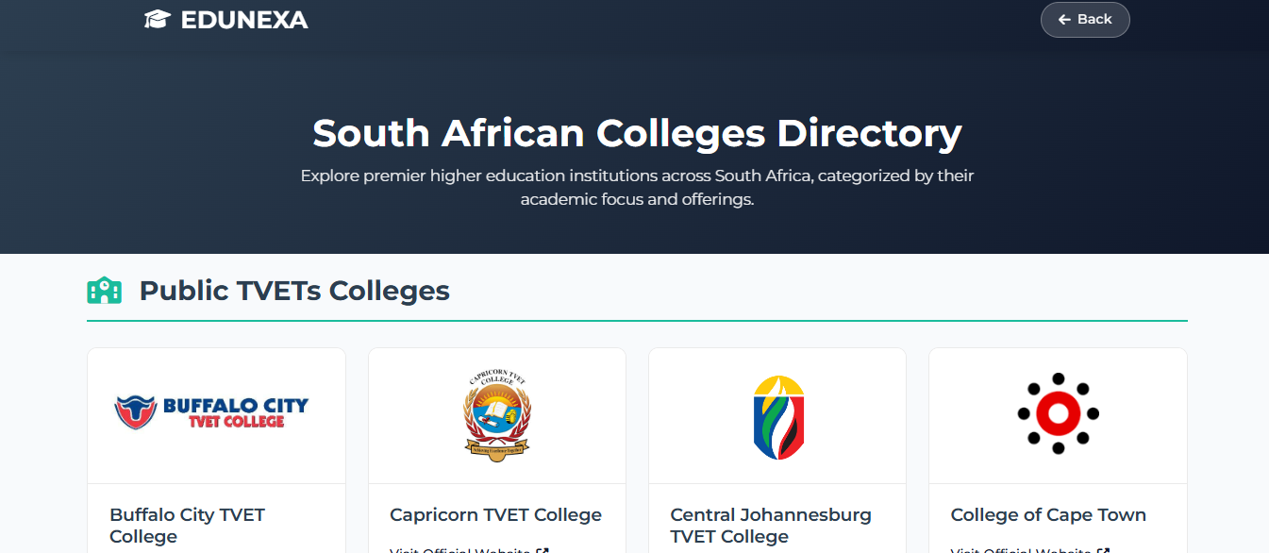

- The user can click Apply for Bursary option, that redirects the user to most of the South African private/public bursaries
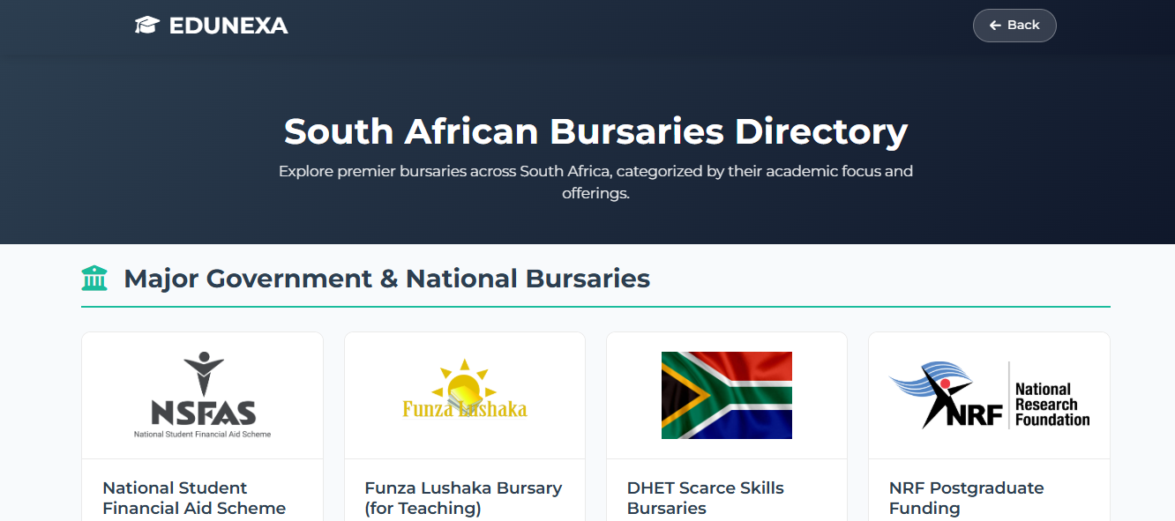
- Each and every bursary has Courses they cover
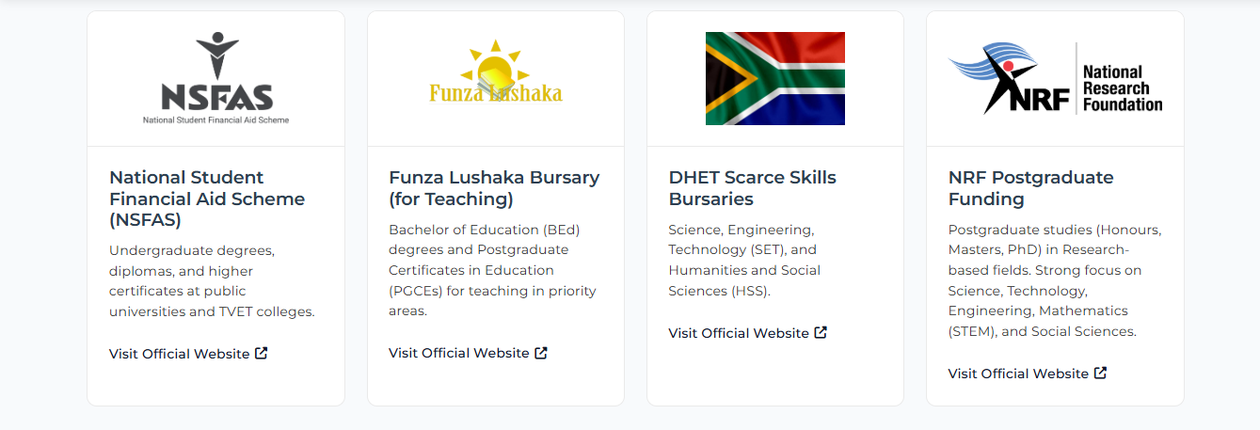
- When the user clicks My Documents / Download Documents, the user is redirected to the same page below that allows the user to optionally attach/download the below attachments:
- Certified ID copy
- Matric Results
- Tertiary Qualification
- Academic Transcripts
- Motivational letter
- Supporting Documents
- Since some of the attached documents expires after 3 months, the user is able to Upload again, which will override the existing attachments and save the new attachments
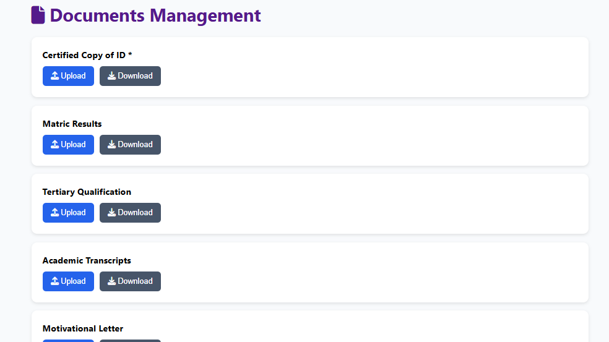
- The user is able to add lots of notes about anything after clicking the + Add New Note button
- The Notes can be Editable after clicking the Edit option
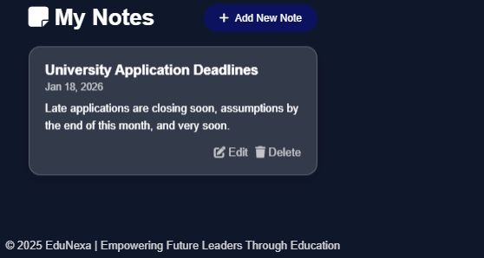
- The user can safely LogOut after clicking the LogOut button and be redirected to the EduNexa Home page



======================THE END ======================

